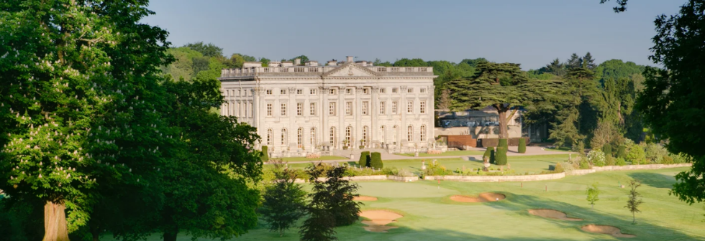

16th December 2021
Dear Golfers

We are delighted to announce the annual African Revival Charity Golf Day will take place on Wednesday 1st June 2022 at Moor Park, and we would like to invite you to join us by pledging a team of four for £895.

Moor Park is a magnificent venue and one of the most impressive private members clubs in the UK. You will be playing on The High Course, a championship course designed by Harry Colt. The High Course features in the Top 100 golf courses in England and is host to many prestigious events including The Carris Trophy.

The day will commence with coffee and bacon rolls from midday with a Shotgun Start at 1.30pm. We will then host a sumptuous three course dinner in a private dining room, with presentation ceremony and auction. A full itinerary will be forwarded closer to the day.

As we continue to navigate through Covid, to alleviate concerns we confirm - if the day does not go ahead due to government restrictions, African Revival will fully refund your entry fee.

I am pleased to update, funds raised at the 2021 golf day are helping to fund the building of a new school at Barifa Primary School in Koboko, Northern Uganda. We will forward a final donor report when the project completes in March/April. Funds raised this year will support the building of another school nearby at Kenybuli Primary School – where there is currently no formal infrastructure and children are learning outside under trees.

Places are limited, I would therefore be grateful if you could confirm your attendance as soon as possible. Please don’t hesitate to contact me with any questions.

We do hope that you will be able to join us for what is always an extremely enjoyable day.

With best wishes
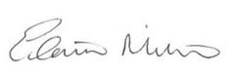
Executive Director
For and on behalf of your host, Steve McPherson, and the African Revival Team

