Celebrated Women - Keeping Girls in Education
Celebrated women are invited to DRAW on their experience to inspire future generations by creating a piece of art, or inspiring message on a postcard.
Once collated, the public will be invited to donate to win one of these unique postcards.
The draw will be made on International Women’s Day - Tuesday 8th March 2022.

Watch this space for how to own a unique signed postcard!
We are inviting celebrated women to support our ‘Keeping Girls in Education’ Fundraiser by creating a unique piece of art or message, which you will have a chance to own!

How can I get involved?
We’ll update you on how you can be in with a chance of owning one of these inspiring creations.
In the meantime, please help raise awareness of our campaign:
- sign up to our e-news bulletin for information
- follow us on our social media and share, like and comment.
- talk about the campaign - word of mouth works wonders!
- get in touch if you would like a campaign pack for your celebrated women / celebrity friends to complete
Why are we fundraising for Girls?
In our primary and nursery schools in Northern Uganda, Southern Zambia, and South Sudan, we have been leading school-based interventions to keep girls in school – primarily addressing issues around menstrual health and sanitation. Our Girls and Sanitation project in Uganda has seen 50% more girls in the final year of primary school after just 1 year! We also ran this project in Zambia where sadly, a girl is more likely to die from childbirth than complete school. These statistics alone are enough to want to act.

By supporting our fundraising campaign, we will help to keep more girls in education, with the aim
of them progressing to secondary school.
“If you educate a man, you educate an individual. But if you educate a woman,
you educate a nation" African Proverb

For more information contact: elaine.miller@africanrevial.org or tessa.kind@africanrevival.org
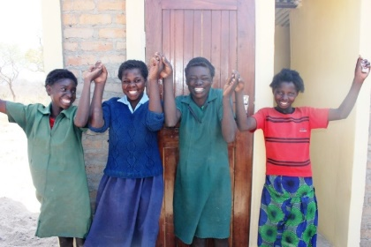
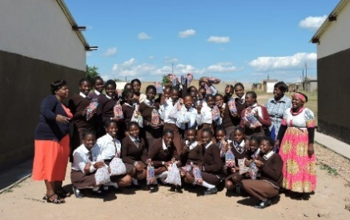

All funds raised will be designated to ‘Keeping Girls in Education’, managed by our Board of Trustees.

