

**Final Donor Report- Model ECD Centre at Kitgum Core PTC**

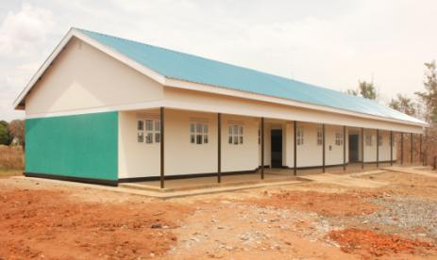

**Background**

**In 2017 donations received enabled African Revival to implement the building of a new model Early Childhood Development Centre at Kitgum Core Primary Teacher College (KCPTC), Northern Uganda.**

**The construction comprised of a block of 1x3 Classrooms and 1x2 Trainee classrooms with office and rest room, 5 stance pupils’ latrines and 2 stance staff latrines. We also provided a playground, furniture, and scholastic material. The project completed and was handed over in March 2018.**

This new facility is are part of the initiative to provide a model Early Childhood Development (ECD) and training centre (the first of its’ kind) in a government setting to set a standard in producing quality nursery teachers (caregivers). The newly qualified teachers will provide relevant expertise required to the learners in schools across the region. Improving the quality of education requires a firm foundation, which in this case is early childhood development. The college is situated in Kitgum and serves the districts of Lamwo - bordering South Sudan, Pader, Agago, Kotido, Abim and other neighbouring districts.

The Communities of these schools have improved in their support of the school programs by contributing towards fencing off the boundary around the school premises. This will provide security for the college property, students and help monitor activities without interference from trespassers. This has been possible through consultative meeting with the school board of governors, college administration and community leadership.

Constructing an ECD facility in the Government owned Primary Teachers College helps to enforce the desired plan for all primary schools to have nursery sections attached to them. This provides an environment where student teachers are monitored and coached by tutors in a practical setting to produce quality and skilled ECD teachers.

**Written by:**

**Ekit Scovia Opuch**

Interim Country Director

And

Vincent Komakech

Construction manager

**African Revival**

**Uganda**

**12th APRIL 2018**

**Image Caption:**

The newly completed ECD classroom block

Model ECD Construction ⬩ Final Report

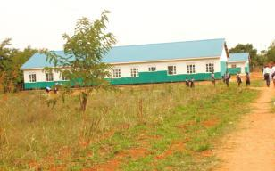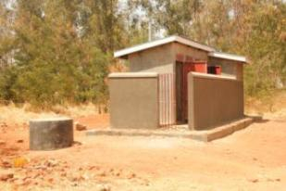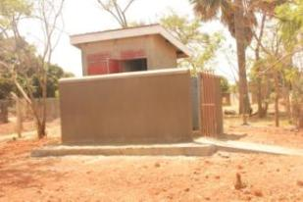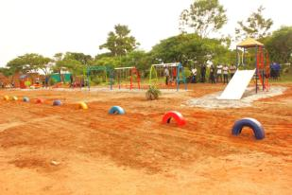**The Need**

Building a strong foundation for a child’s emotional, social, physical and mental development is a lifetime approach.

Early childhood educators need to be trained in identifying areas where support is required for each child and building programs around these to enhance their development.

The Teacher Training College initially focused on primary and secondary school teachers while omitting nursery education.

African Revival in partnership with KCPTC identified this gap and sought funding to address the need. The result is an established model ECD training centre with a tailored curriculum according to the Ministry of Education and Sports (MOES) to provide an all-round child centred teacher thus giving a concrete foundation to maximise their future well- being.

AR has been working with KCPTC to train and deploy about 200 qualified teachers annually to Acholi sub region and beyond with a keen focus on improving the enrolment of female trainees who would thus complete and be posted in the rural primary schools.

Kitgum now has a model Early Childhood Development wing, complete with all the required facilities, including an bright and engaging playground for the children to develop their motor skills through play.

We are optimistic that this centre will become a model offering best equipped nursery educators demonstrated by the number and quality of pupils transitioning to primary level.

THANK YOU

Model ECD Construction ⬩ Final ReportAR ssp logo

**Project Implementation**

Work began on the 1st Dec 2017, with a formal site handover to the selected contractor in the presence of the community and district leaders.

The district leadership welcomed the intervention and pledged to work alongside AR to ensure that value for money is achieved. The contractor mobilised materials and human resource needed to take-off the project.

Periodic inspection and supervision of the progress of works were done jointly with the District technical team and the College administration.

The design provides for 75 learners comfortably sitting in the 3 classrooms with extra accommodation. 54 trainees will be enrolled in each level /class thus the ECD to benefit up to 200 people including employees.

Parents are supportive and are happy to contribute resources for the sustainability of the program.

During the handover, the principal – Christine Chandiru appreciated AR (African Revival) and she had this to say. “*I thank AR for being a long- term development partner and supporter of the College. Thanks to AR, the College now boasts of 2 blocks of female dormitories with beds, fencing off the girl’s dormitory area, 12 stances latrines and renovation of the library block!”….*

Kitgum Core Primary Teachers College (KCPTC) also has a demonstration primary school attached to it, making the nursery a complete cycle of pre-primary and primary education.

There are still other challenges that include: power outages, lack of running water, furniture and incomplete perimeter wall fence that pose security threat.

The Management has pledged their commitment to fence off the ECD area, enrol learners for the new term and establish a team that will oversee its management and implementation.

The Municipal Education Officer- Mrs. Atim Harriet Okot said “*I* *appreciate very much the support given to Kitgum district as this would go a long way in improving the quality of education with nursery education being the foundation”*

During the handover, attended by District Officials and Tony Allen, Founder and Chairman of African Revival, emphasis was made on the community to take good care of the facility for an improved quality of learning environment, enrolment of children and attendance.

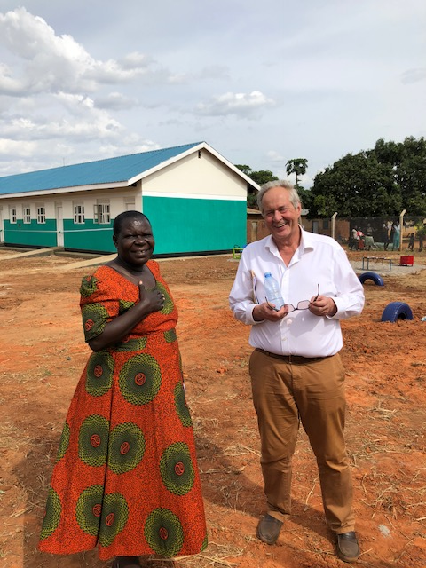 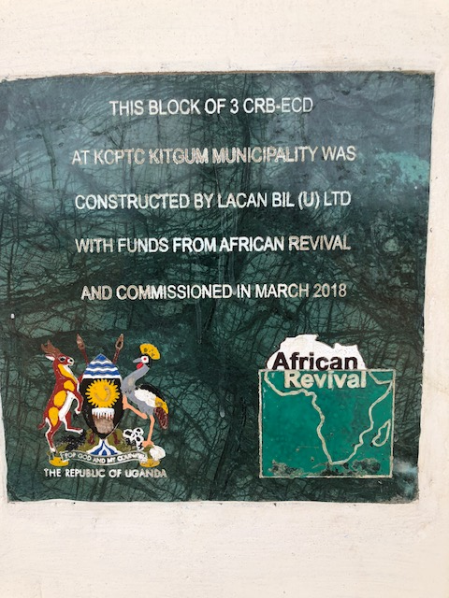

Model ECD Construction ⬩ Final ReportAR ssp logo

**Progress in Pictures**

**December**

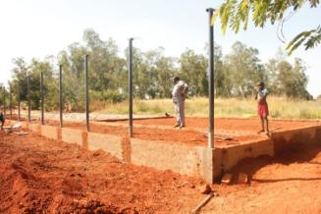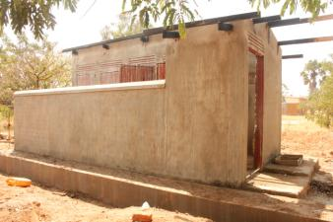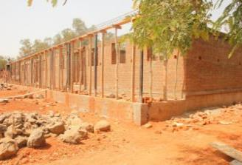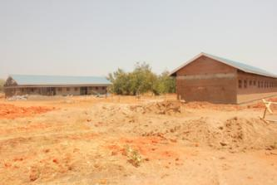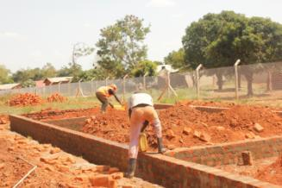

**Clockwise from top left:**

* Plinth walls, substructures and superstructures for classroom block, plastering the latrine block

**January**

Model ECD construction ⬩ Final ReportAR ssp logo

**Progress in Pictures**

**February**

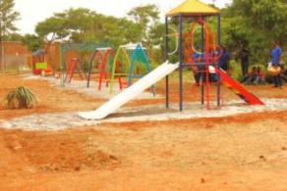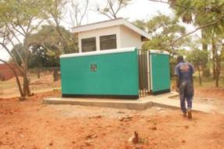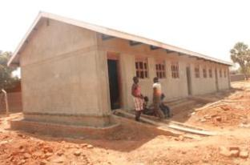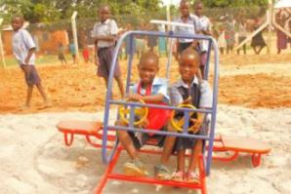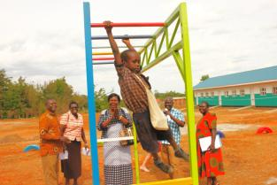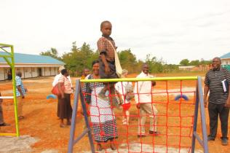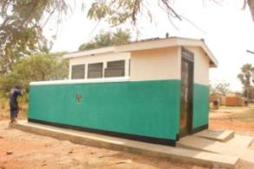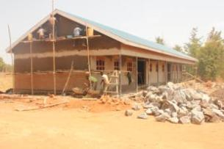

ECD construction at KCPTC ⬩ Final ReportAR ssp logo

**Budget and Expenditure**

The construction of 1 x block of 3 classrooms, 1 x block of 2 classrooms, with office and rest rooms, 1 x block of 2 stance latrines for staff, 1 x block of 5 stance pupil drainable latrines, a large playground, classroom furniture and scholastic material.

The total project cost was **£86,300**.

For more information about this project, or general enquiries, please contact:

[scovia.ekit@africanrevival.org](mailto:scovia.ekit@africanrevival.org) in Uganda, or   
  
[elaine.miller@africanrevival.org](mailto:elaine.miller@africanrevival.org) in the UK office - 020 8939 3190

**Thank you for your time, commitment and support**

**for African Revival**

African Revival, 159a High Street, Hampton Hill, TW12 1NL

Telephone: 020 8939 3190  
<http://www.africanrevival.org>

Registered charity number 1108718 (England and Wales)

**…to this…**

**From this…**

**…to this!**

