Emergency Sanitation Fund

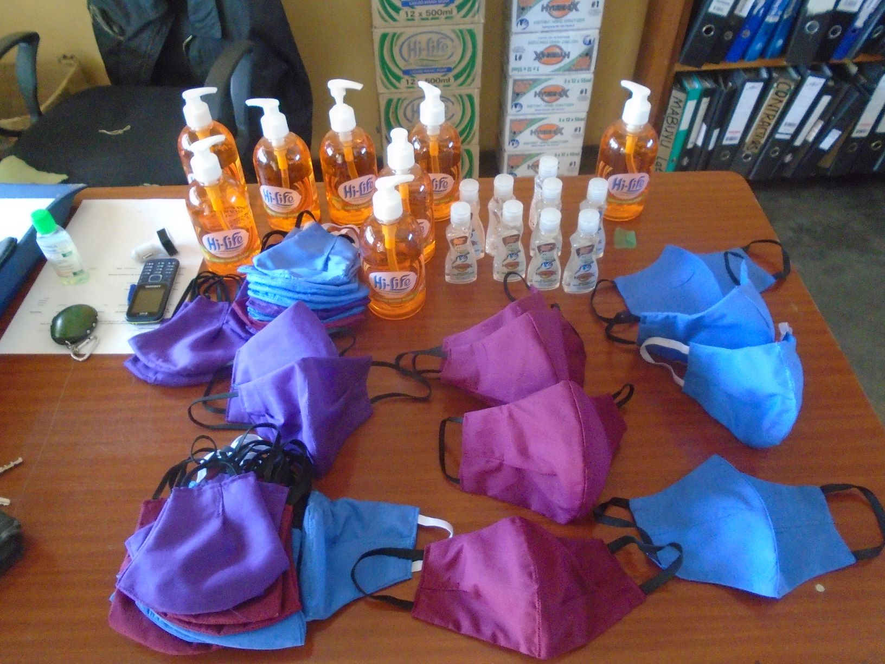

Introducing African Revival:
Our vision is an Africa where every child has equal access to quality education as we believe education is the key to overcoming poverty. Since 2004 we have worked with primary and nursery schools in Uganda, Zambia and South Sudan. We don’t just provide infrastructure; we empower whole communities – pupils, teachers and parents – to transform schools into thriving learning environments that build better futures. The end goal is simple: to improve equal access to quality education.

Overview of Project:
In Country Office | Zambia
Project Name | Emergency Sanitation Fund
Project Location | Kansumo, Namabondo and Simbunji Community Schools, Kalomo District, Southern Province, Zambia
Historical support | African Revival has been supporting these schools for many years with various construction projects, and our Girls & Sanitation programme. Play It Forward (formerly ATD Foundation) have funded several of these projects. Due to the outbreak of Covid-19, Play it Forward approved funding for interventions aimed at preventing the spread of Coronavirus.
Was this project located within an existing programme or new? | This was a new stand-alone Covid-19 intervention project to construct permanent hand washing facilities, provide PPE for teachers and pupils, and rehabilitate 1 borehole. These interventions were implemented at 3 community schools.
Project Goal and Outcomes | Project Goal: Improved sanitation and hygiene to help prevent the spread of Covid-19.  Outcome 1: Hand Washing Stands constructed  Outcome 2: Borehole refurbished  Outcome 3: PPE supplied – masks/soap/sanitisers
Target Population | 766 pupils (395 girls and 371 boys) and 26 teachers
Project Implementation | 1 Month (completed June 2020)
Project Budget | £2012.18
Donor | Play it Forward
Contact Person in Zambia | Name: Godwin Kamangala – Country Manager  Email: Godwin.kamangala@africanrevival.org

Background:
In 2019 Coronavirus, known as Covid-19, broke out in China and began to spread rapidly to other parts of the world. Zambia was not left out; cases that began with 1 confirmed case increased to over 1,500, with 42 deaths reports (as at 8th July 2020). Government announced several measures to protect its people. Schools, colleges and universities and other facilities were closed, and emphasis was made on promoting high hygiene and sanitation standards. A month later government lifted the ban on examination classes and allowed schools to open their doors to this category of school going children but with continued emphasis on ensuring that schools provided hygiene facilities and Person Protection Equipment so that returning pupils are protected from Covid-19.

Most schools could not afford to provide these facilities due to lack of financial resources. African Revival joined other organisations in supplementing government efforts in the fight against Covid-19 and sourced funding from Play it Forward (formerly ATD Foundation), to implement interventions in the three schools previously supported by the donor.

Play it Forward approved funding to construct permanent hand washing facilities, procure liquid soap and hand sanitisers, and provide PEP for teachers as well as sanitary pads for girls. In addition, African Revival proposed to refurbish the broken borehole at Simbunji Community School as water was critical to maintaining the required hygiene standards. The budget also included printing of posters on prevention of spreading germs. All these interventions supported 766 pupils (395 girls and 371 boys) and 26 teachers in the 3 schools.

Community Engagement:
Before the project commenced, African Revival agreed with the community - parents and teachers - to quickly mobilise river sand, stones, bricks and other local materials for the construction. Community involvement is important for sense of ownership and helps reduce costs of the project. As well as providing upfront materials the community also provided labour. Parents quickly agreed to assist in fetching water to support the professional builder that we hired to speed up the work. Our Construction Coordinator, Dave Sangweni, and the builder/contractor were on hand to supervise and work together with the community.

Project Delivery:

African Revival constructed permanent hand washing stands, procured 99 bottles of liquid soap, 192 hand sanitisers, and 39 face masks for staff as well as 48 sanitary pads for girls in examination classes that had reported back to school. The Simbunji borehole was also refurbished. 20 posters were also printed and displayed in and around the schools to provide information on prevention of spreading germs. The handwashing facilities are located outside the classrooms.

ITEM | SCHOOL
 | Kansumo | Namabondo | Simbunji
Liquid soap | 33 | 33 | 33
Hand sanitizer | 64 | 64 | 64
Masks | 13 | 13 | 13
Sanitary pads | 0 | 0 | 48
Posters | 20 | 20 | 20
Small plaques | 1 | 1 | 1
Borehole rehabilitation |  |  | 1

Project Results:
Outputs: Construction of permanent hand washing stands, refurbishment of 1 borehole (though the yield is low due to a low water table), procurement of 99 bottles of liquid soap, 192 hand sanitisers, 39 face masks, 48 sanitary pads, printing of 3 plaques and 60 posters.

Outcomes:
766 pupils (395 girls and 371 boys) and 26 teachers in the 3 schools have immediately benefited from these interventions.

Impact:
It is expected that these interventions will contribute to the prevention of the virus and other germs in the selected schools. This will help pupils to focus on school with less concern about contracting Covid-19. Ultimately this will contribute to improved academic performance in the exams.

Budget Summary:
African Revival received a funding total amount of £2012.18 to support this project, which finished with an under-spend of £96.03. With donor approval AR will procure additional soap for the schools.

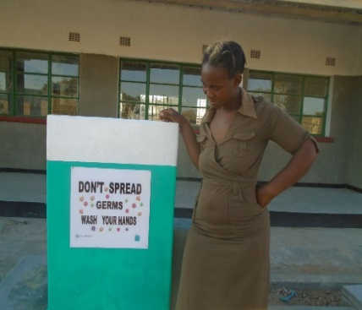
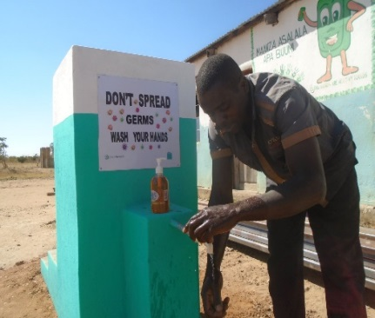
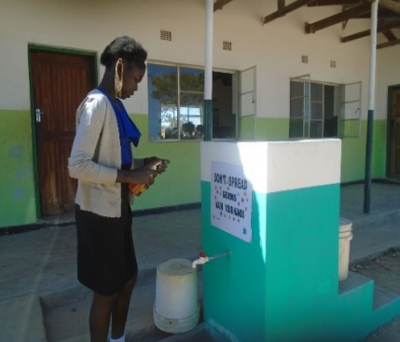
Project Pictures:
Caption: Hand washing stands
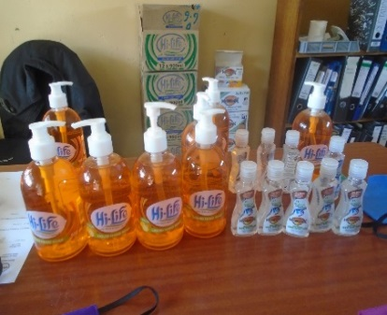
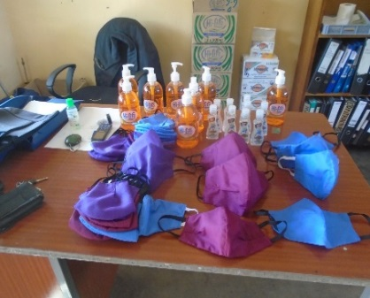
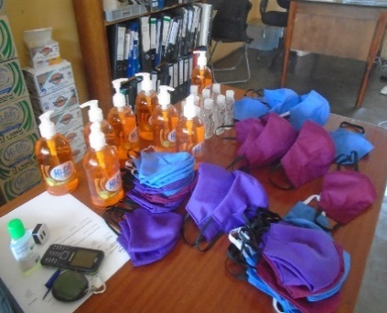
Caption: Liquid soap, hand sanitisers and face masks

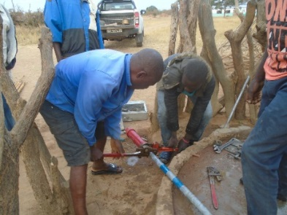
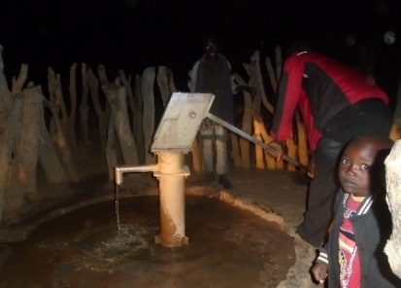
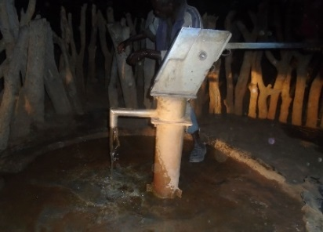

Caption: Borehole rehabilitation at Simbunji Community School

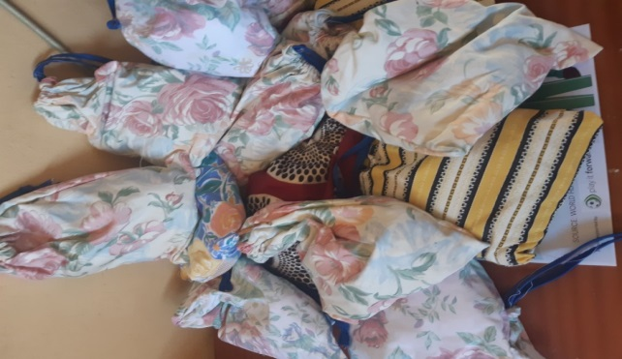
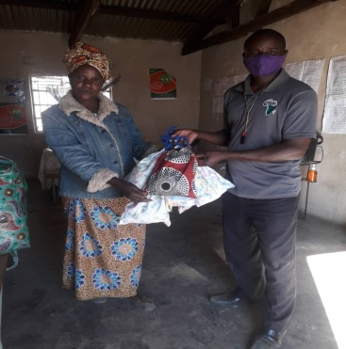

Caption: Sanitary pads delivered

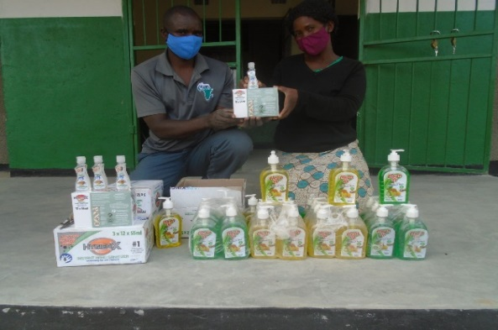
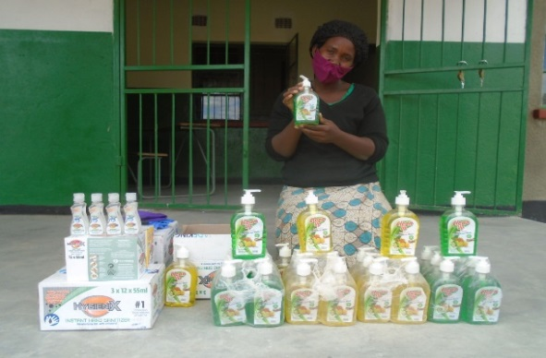
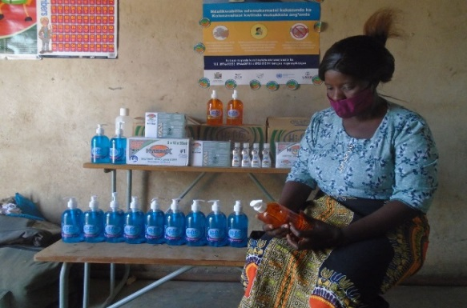
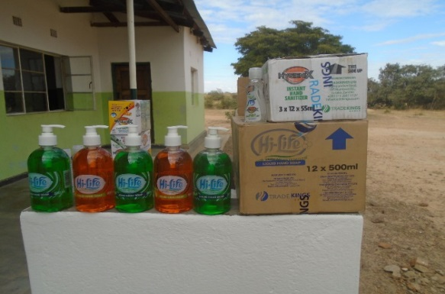
Caption: Schools receiving various items

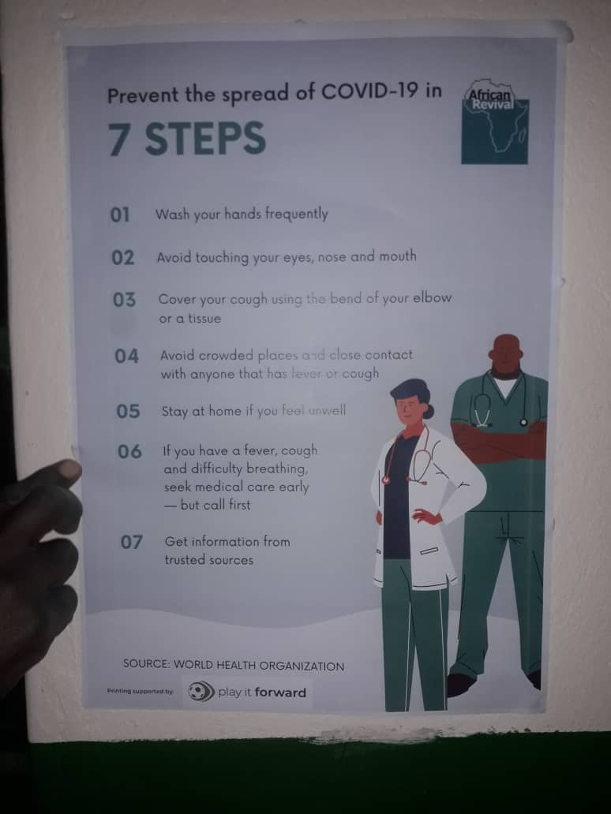
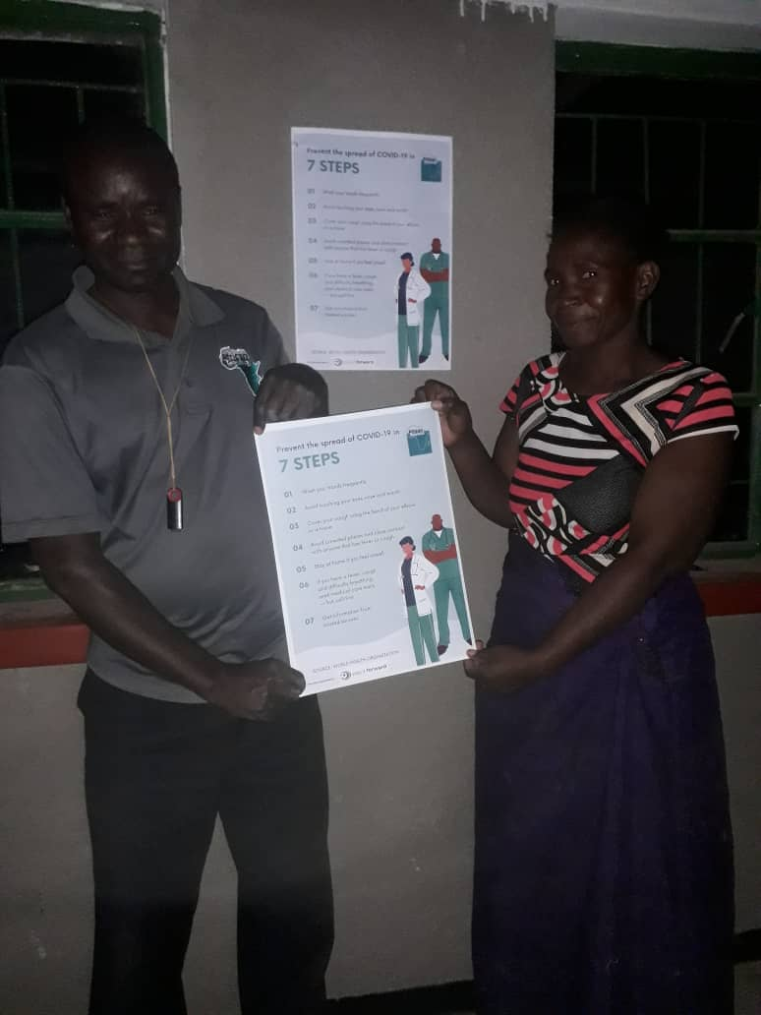

Caption: Dave Sangweni from African Revival delivering Posters to teachers.
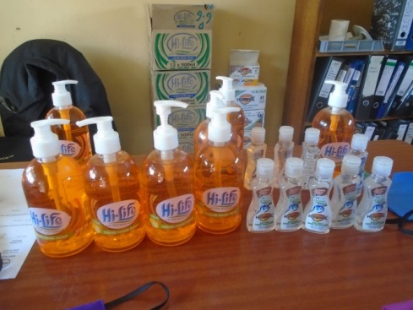
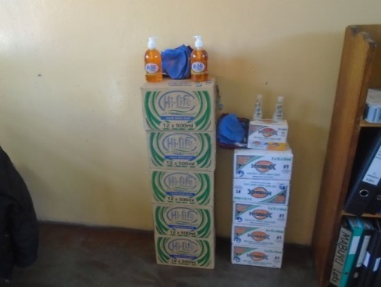

Thank you to Play it Forward from all of us at African Revival

